**To Do List Application**

**Output**

**Test 1: Menu**

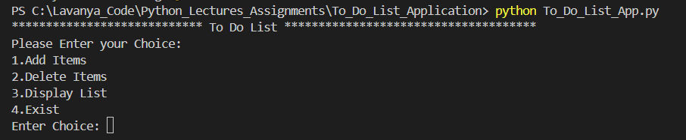

**Test 2: Exist From Menu**

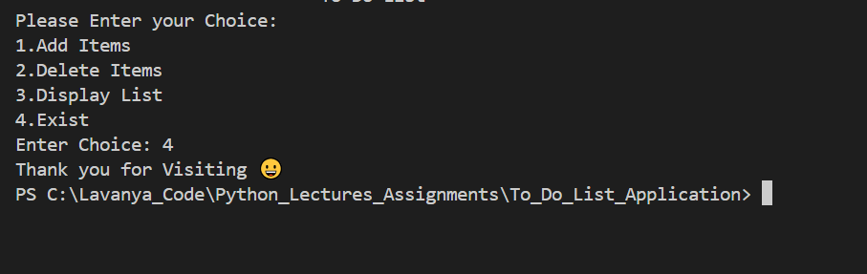

**Add Items**

**Test 1: Add Items**

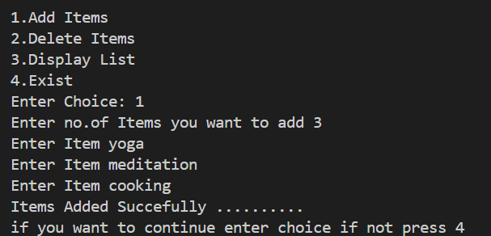

**Display Items**

**Test 1: List is empty**

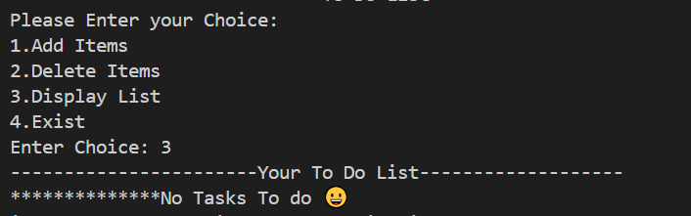

**Test 2: List having Items**

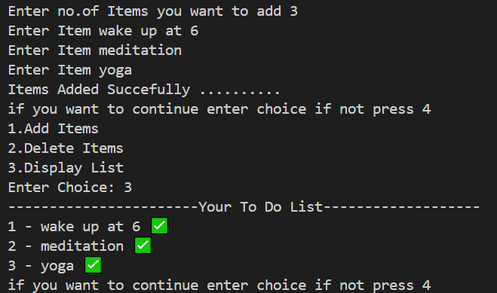

**Delete Items**

**Test 1: When no Items**